**Project Planning Phase**

**Project Planning (Product Backlog, Sprint Planning, Stories, Story points)**

|  |  |
| --- | --- |
| Date | 18 October 2022 |
| Team ID | PNT2022TMID51470 |
| Project Name | Project – Web Phishing Detection |
| Maximum Marks | 8 Marks |

**Product Backlog, Sprint Schedule and Estimation (4 Marks)**

**Product backlog and sprint schedule:**

|  |  |  |  |  |  |  |
| --- | --- | --- | --- | --- | --- | --- |
| **Sprint** | **Functional**  **Requirement (Epic)** | **User Story**  **Number** | **User Story / Task** | **Story Points** | **Priority** | **Team**  **Members** |
| Sprint-1 | Homepage | USN-1 | As a user, I can explore the resources of the homepage for the functioning | 10 | Low | P Paul Galvin,  M Sugadev, J Steen Rohan, A Boobathy Ram, S Vignesh |
| Sprint-1 |  | USN-2 | As a user, I can learn about the various sides of the web phishing and be aware of the scams | 5 | High | P Paul Galvin,  M Sugadev, J Steen Rohan, A Boobathy Ram, S Vignesh |
| Sprint-2 | Final page | USN-3 | As a user, I can explore the resources of the final page for the functioning | 15 | Low | P Paul Galvin,  M Sugadev, J Steen Rohan, A Boobathy Ram, S Vignesh |
|  |  |  |  |  |  |  |
| Sprint-3 | Prediction | USN-4 | As a user, I can predict the URL easily for detecting whether the website is legitimate or not | 10 | High | P Paul Galvin,  M Sugadev, J Steen Rohan, A Boobathy Ram, S Vignesh |
|  | Dashboard |  |  |  |  |  |
| Sprint-4 | Chat | USN-5 | As a user, I can share the experience or contact the admin for the support | 10 | High | P Paul Galvin,  M Sugadev, J Steen Rohan, A Boobathy Ram, S Vignesh |
|  |  |  |  |  |  |  |
| Sprint-1 | Homepage | USN-6 | As a admin, we can design interface and maintain the functioning of the website | 5 | High | P Paul Galvin,  M Sugadev, J Steen Rohan, A Boobathy Ram, S Vignesh |
| Sprint-2 | Final page | USN-7 | As a admin, we can design the complexity of the website for making it user-friendly | 5 | Medium | P Paul Galvin,  M Sugadev, J Steen Rohan, A Boobathy Ram, S Vignesh |
|  |  |  |  |  |  |  |
| Sprint-3 | Prediction | USN-8 | As a admin, we can use various ML classifier model for the accurate result for the detection of  URL | 10 | High | P Paul Galvin,  M Sugadev, J Steen Rohan, A Boobathy Ram, S Vignesh |
|  | Dashboard |  |  |  |  |  |
| Sprint-4 |  | USN-9 | As a admin, we can response to the user message for improvement of the website | 10 | Medium | P Paul Galvin,  M Sugadev, J Steen Rohan, A Boobathy Ram, S Vignesh |

**Project Tracker, Velocity & Burndown Chart (4 Marks)**

|  |  |  |  |  |  |  |
| --- | --- | --- | --- | --- | --- | --- |
| **Sprint** | **Total Story Points** | **Duration** | **Sprint Start Date** | **Sprint End Date (Planned)** | **Story Points**  **Completed (as on**  **Planned End Date)** | **Sprint Release Date (Actual)** |
| Sprint-1 | 20 | 6 Days | 24 Oct 2022 | 29 Oct 2022 | 20 | 29 Oct 2022 |
| Sprint-2 | 20 | 6 Days | 31 Oct 2022 | 05 Nov 2022 | 20 | 05 Nov 2022 |
| Sprint-3 | 20 | 6 Days | 07 Nov 2022 | 12 Nov 2022 | 20 | 12 Nov 2022 |
| Sprint-4 | 20 | 6 Days | 14 Nov 2022 | 19 Nov 2022 | 20 | 12 Nov 2022 |

**Velocity:**

Imagine we have a 10-day sprint duration, and the velocity of the team is 20 (points per sprint). Let’s calculate the team’s average velocity (AV) per iteration unit (story points per day)

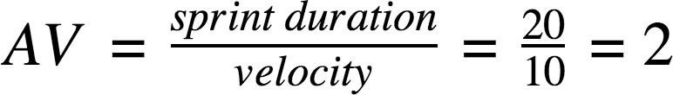

We have a 6-day sprint duration, and the velocity of the team is 20 (points per sprint). So our team’s average velocity (AV) per iteration unit (story points per day)

# AV = (Sprint Duration / Velocity) = 20 /6 = 3.33

**Burndown Chart:**

A burn down chart is a graphical representation of work left to do versus time. It is often used in agile [software development m](https://www.visual-paradigm.com/scrum/what-is-agile-software-development/)ethodologies such as [Scrum.](https://www.visual-paradigm.com/scrum/scrum-in-3-minutes/) However, burn down charts can be applied to any project containing measurable progress over time.

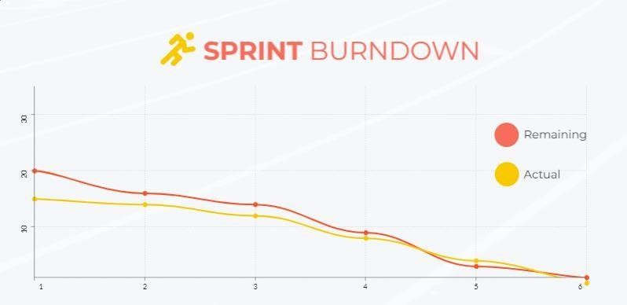

**Reference:**

**https://**[**www.visual-paradigm.com/scrum/scrum-burndown-chart/**](http://www.visual-paradigm.com/scrum/scrum-burndown-chart/)  **https://**[**www.visme.co/templates/charts/sprint-burndown-chart-1425285230/**](http://www.visme.co/templates/charts/sprint-burndown-chart-1425285230/)